FACTSHEET REACHING THE TOP

The Mount Everest Expedition of 1953 was led by Colonel John Hunt. This was to be the first attempt on Mount Everest from the Nepalese side.

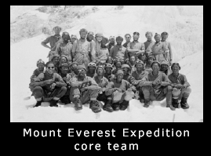
The photo on the right shows the core team but the 1953 expedition totalled over 400 people. The expedition also carried with it 7¹/₂ tons (8333 kg) of equipment in 443 packages. Their contents included the expedition’s food, climbing equipment and camping kit for their three month stay.

On March 10th, the huge expedition left Kathmandu and started on its 175 miles (282 km) walk in to the Everest region. It had to split into two walking groups because of the sheer size of the expedition. The trek took the team through countryside dotted with small villages, blooming flowers, ice cold streams and magnificent views. And after 7 days, the team got their first glimpse of the mighty mountain itself.

After a further nine days, the expedition reached Thyangboche. This is a small settlement at 12,000 feet (3,658 m) with a gompa or monastery at its heart, yaks grazing at its edge. The team spent three weeks here for rest and ‘acclimatisation’ which involved gradually getting used to being at increasing altitudes. Their stay at Thyangboche also provided time to practice using the team’s new oxygen equipment.
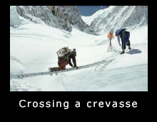
On 12th April, Base Camp was established at 17,900 feet (5,456 m) to the side of the Khumbu Icefall, one of the main physical obstacles to the peak of Mount Everest. A special team began to prepare the way up this stretch of glacier that was continually moving and groaning under their feet. Camp II was pitched half way up the Icefall but was later abandoned because it was too unsafe. The threat of opening crevasses and gigantic tumbling blocks of ice was constant. Amazingly, the team and the Sherpas managed to get through the Khumbu Icefall without accident.

From Camp III at the top of the Icefall (at the entrance to the Western Cwm), the team had to cross the massive Bergschrund crevasse using a ladder. In many places, the route had to be identified by marker flags to help prevent people getting lost. Camp III was the point where all the team donned their high altitude equipment, including their specially made high altitude boots.

Camp IV (21,200 feet, 6462 m) was home to the expedition’s Advance Base Camp from which they were to make their first preparations for the final climb. There were several more camps before the final one at 27,900 feet (8504 m), high up in the cloud, freezing temperatures and raging winds. On May 26th, Tom Bourdillon and Charles Evans pushed towards the summit and made it above the high point set by the Swiss expedition the year before. Bourdillon and Evans came within 300 vertical feet of the summit.

Two days later, the expedition’s last hope for the success rested on the second and final attempt for the summit to be made by Edmund Hillary and Tenzing Norgay. A five man team helped the pair to establish a camp as high up the mountain as possible giving them the best chance of reaching the summit on the big day and then they were left on their own. The pair spent the night of 28th May hardly sleeping and breathing oxygen, wedged inside a precariously positioned tent. They ate delicacies from their store such as tinned apricots, sardines on biscuits, dates, jam and honey and lots of liquids to try and beat the terrible dehydration.

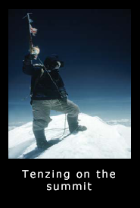
At 6.30 am, Hillary and Tenzing crawled from their tent. By 9 am they had reached the South Summit and then had a grim struggle up the ridge. At 11.30 am, Hillary and Tenzing stepped on to the top of the world’s highest mountain.
Hillary produced a camera loaded with colour film that he had been keeping warm inside his shirt and took the famous photo of Tenzing holding his ice axe with the British, Nepalese, United Nations and Indian flags attached. Tenzing made a hole in the snow and placed in it small offerings to the Buddhist gods and Hillary placed the expedition leader’s crucifix beside them.

