Lesson Six: New York through time
Factsheet for teachers
New York City, located at the mouth of the Hudson River in the North Eastern US, is of the largest and arguably the most influential cities in the world. The purpose of this lesson is to provide an opportunity for pupils to investigate how New York City has developed over time, some of the factors that have led to this development and what challenges the city faces today.
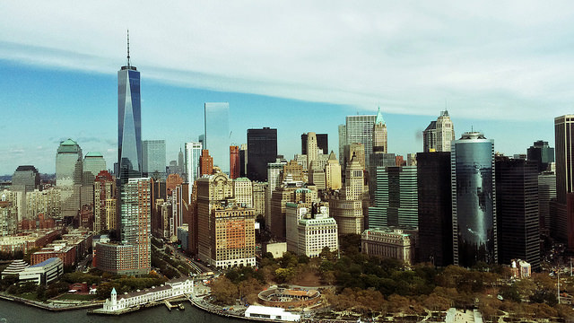New York © Phil Dolby, Flickr
Key facts
- The current population is estimated at 8.5 million distributed over a land area of just 305 square miles; making it one of the most populous cities in the world.
- The city is made up of five boroughs: Manhattan, Bronx, Brooklyn, Queens and Staten Island.
- Most of New York City is built on the three islands of Long Island, Manhattan, and Staten Island. The Hudson River flows through the Hudson Valley into New York Bay.
- Many districts and landmarks in New York City have become well known, and the city received a record 56 million tourists in 2014.

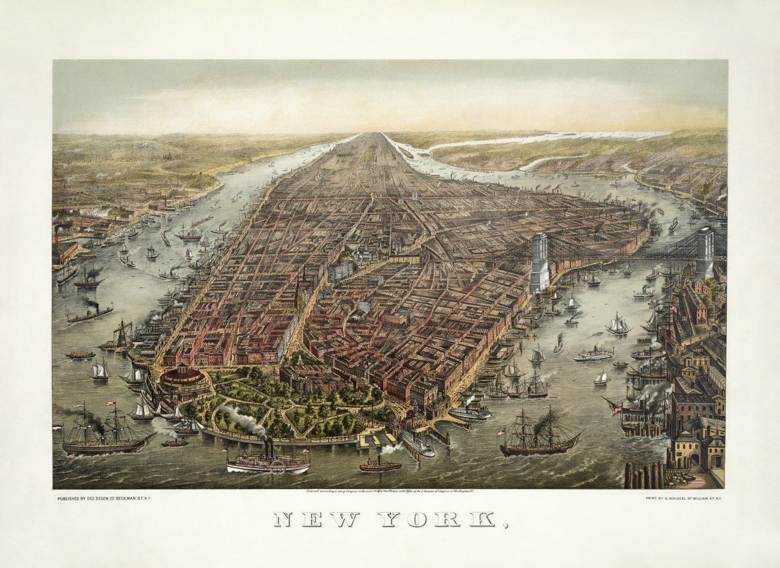©Wikipedia
This video provides a detailed overview of how New York has changed over the last 400 years: http://www.ted.com/talks/eric_sanderson_pictures_new_york_before_the_city?language=en
There are number of online resources which you can also visit to explore how the city has changed:
- Watch this video which explores how New York has changed over time: https://www.youtube.com/watch?v=kOrgslc1-Ek
- An interactive map which shows how the city has changed since 1836. http://www.smithsonianmag.com/history/interactive-map-compares-new-york-city-1836-today-180947939/?no-ist
- To explore differences between New York in the 1960s and today visit this website http://www.nyc-grid.com/.

Did you know? The phrase the Big Apple was first popularized in the 1920s by John J. Fitz Gerald, a sports writer for the New York Morning telegraph. In the early 1920s “apple” was used in reference to the many racing courses in and around New York City. Apple referred to the prizes being awarded for the races. John J. Fitz Gerald then coined the term ‘Big Apple’ in reference to one of these prizes.

