“Why does Manchester’s water have ghosts?”
Name: __________
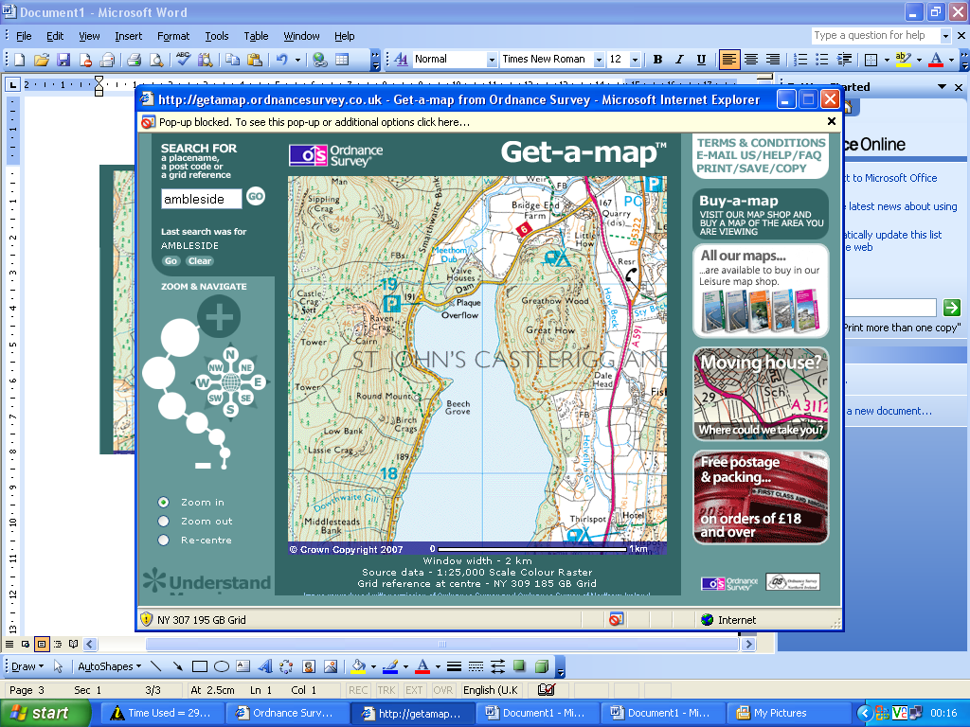
Why is this campsite located here?
Who benefits from this Dam?

At the church, looking at the graves and inside the church at the war memorial and other literature in the church, solve the mystery as to why there are ghosts in Manchester’s Water.
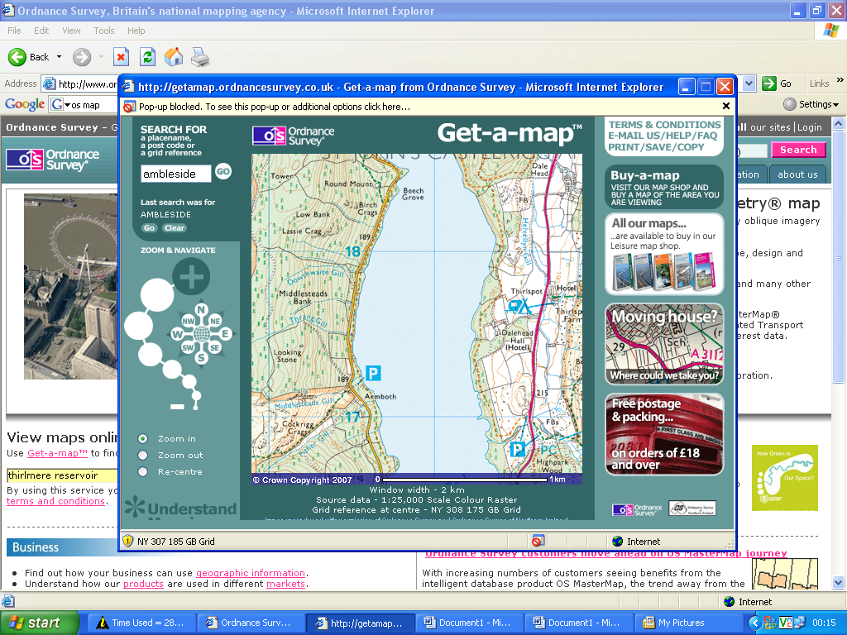
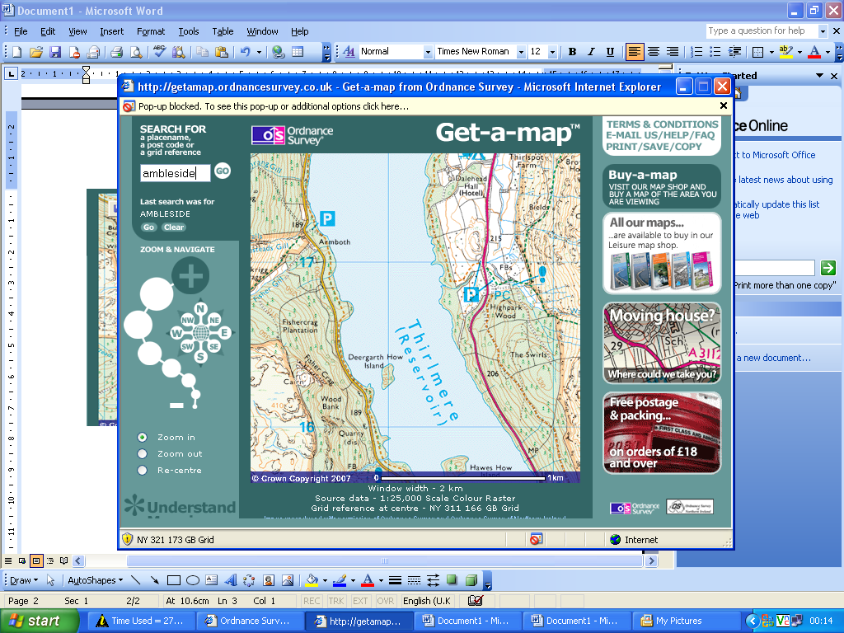
Why are no motor boats allowed here?

Why is the water so blue?

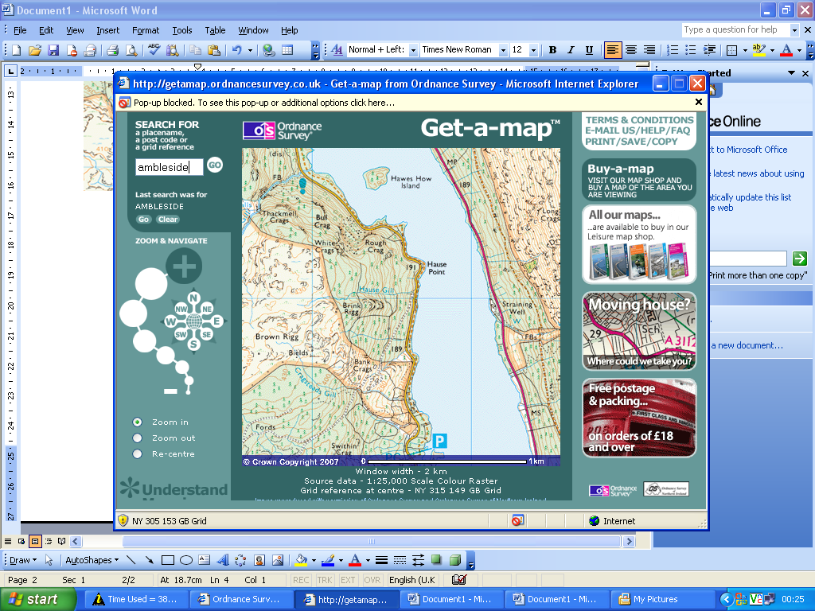
Why are there trees planted around this lake?

Why have some of them been felled?
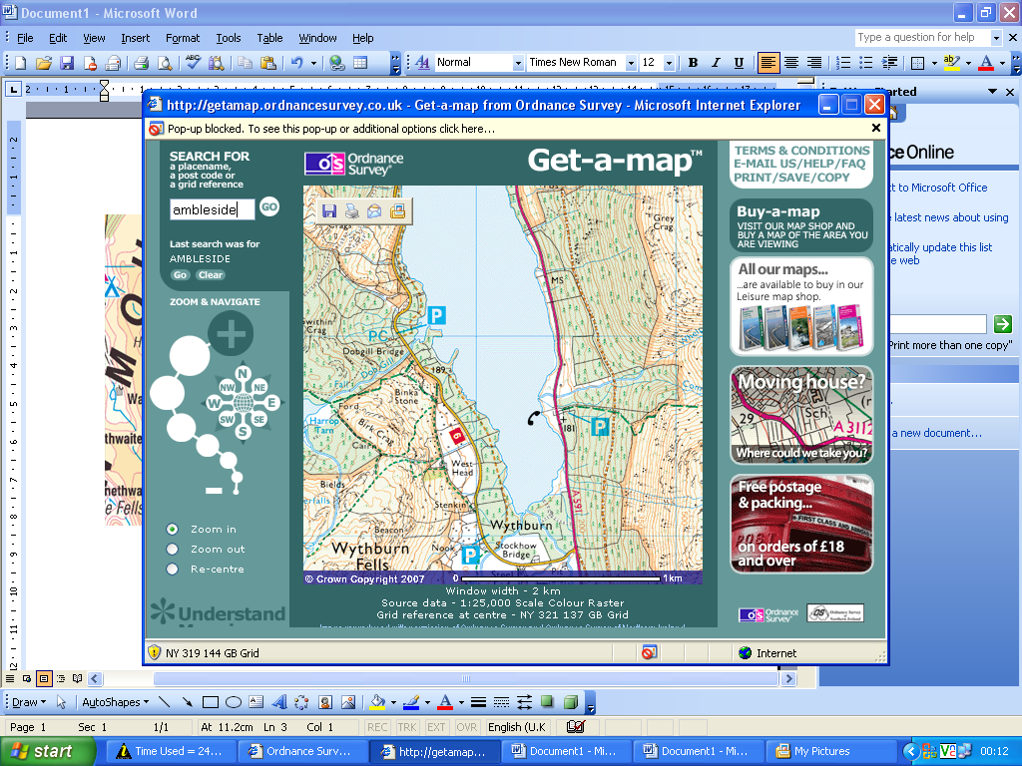
Why is there no camping or swimming?

Looking at the valley what might you normally find here?

Name: _________________
Date: __________________

Fieldsketch worksheet
* Make sure your annotations are detailed and relate to physical and human aspects of the environment

Detail of site:

Details of site:

Ecology of the reservoir area:

Purpose of reservoir:
Demand for water:

Uses of reservoir/area:
Physical consequence of damming:
Human consequence of damming:
Concept Map
- Thirlmere Reservoir
Times of drought:

Current issues:

Recreational possibilities:

I LEARNT THAT… | I ENJOYED….
I NOW UNDERSTAND THAT… | MY FAVOURITE PART OF THE ACTIVITY WAS…
I NOW KNOW THAT… | MY LEAST FAVOURITE PART OF THE ACTIVITY WAS…
I LIKED…. | I UNDERSTAND….

