Lesson two
Canyons and Valleys: Physical Landscapes
Factsheet for teachers
Purpose of this lesson
The purpose of this lesson is to introduce pupils to some of the different features of the landscape in the USA. In particular the lesson will introduce the processes of erosion and how these affected the formation of the Grand Canyon. This includes a practical demonstration to show how water can erode the landscape.
The lesson begins by watching a video of different landscapes in the USA. Go to Vimeo website https://vimeo.com/63186969
Pupils should complete the A to Z worksheet by trying to identify words for things they see in the video. A-Z teacher’s hints are provided which has suggestions for each letter. This can be used to begin to discuss the different types of physical landscapes, features and processes in the USA.
Pupils should be shown this image (as included in the lesson PowerPoint) and asked how they think it might be formed.
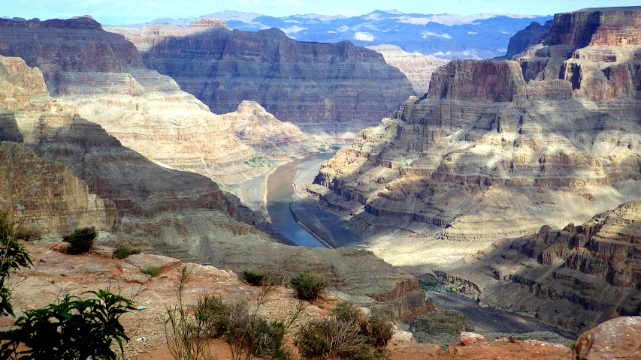
Grand Canyon © Amy Felce, Flickr
The making of the Grand Canyon
The Grand Canyon in northwest Arizona formed by the immense, erosive power of the Colorado River It is 446 km (277 miles) long, up to 29 km (18 miles) wide and more than 1,800 meters (6,000 feet) deep. It is millions of years old and has carved itself from the Rocky Mountains to the Gulf of California, deep into the Colorado Plateau.
You can view a panoramic view of the Grand Canyon here. Go to NPS website http://www.nps.gov/grca/planyourvisit/upload/grca_pano.pdf
The Colorado River flows through the Grand Canyon. The canyons climate is semi-arid, where some parts around the upper plateau have some areas of forest, while the lower layers near the canyon bottom are more like desert basins.
About 50 million years ago, the collision of two tectonic plates caused the land to be raised and elevated. The rock layers of the Colorado Plateau (which are sedimentary rock deposits) covering a much older basement rock, remained. Because the rock layers have varying degrees of hardness, resistance to the erosive power of the water (in particular the Colorado River) also varies. The soft layers of rock erode quicker than the hard layers. This produces its distinct step-like profile. Extreme temperature changes, from hot to cold, root pressure or strong wind can also loosen and disintegrate rock on the valley sides. There are around 40 identified rock layers in the walls of the Grand Canyon.
The Grand Canyon is a gorge created by tectonic uplift of the Colorado Plateau. As tectonic plates beneath the Earth’s crust shift and collide, their movement can change the area’s landscape. Sometimes, tectonic activity causes an area of the Earth’s crust to rise higher than the surrounding land. This process is called tectonic uplift. Tectonic uplift can create plateaus and mountains. Rivers and glaciers that cut through these elevated areas of land create deep canyons. Geologist’s debate the age of the canyon itself—it may be between 5 million and 70 million years old. In 1908 the Grand Canyon was made a National Monument by President Theodore Roosevelt in order to protect it from human development.
A canyon is a deep, narrow valley that has steep sides. The word canyon is derived from the Spanish word canon which means ‘tube’ or ‘pipe’. Sometimes the word ‘gorge’ is used to mean canyon, however a gorge is usually much steeper and more narrow than a canyon. As with other river canyons, water pressure can cut deep into a river bed. The eroded material is carried downstream, creating a deep, narrow channel. While the Grand Canyon is very deep, it is not the deepest in the world – the Yarlung Zangbo Grand Canyon in Tibet is the deepest in the world reaching nearly 5,300 m in some place. It is also one of the longest canyons, reaching around 500km.
To explore the detailed geology of the Grand Canon go to R Clark website http://rclark.github.io/grand-canyon-geology/
Watch this video to travel along the Grand Canyon go to Live Science go to Live Science website http://www.livescience.com/27489-grand-canyon.html

Erosion
Erosion is the process where material such as sand and rock are worn away. Erosion can be caused by water (and ice), wind, chemicals.
There are four key processes of erosion in a river as show in the diagram:
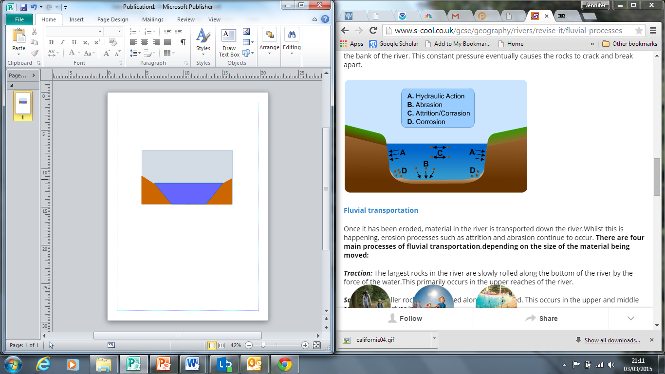
Erosion © Wikipedia
- Hydraulic Action: The water forces air to become trapped and pressured into cracks in the riverbank. This eventually forces the rocks to crack and break off.
B. Abrasion: Erosion of the bottom of the river and the river sides by material being carried by the river and dragged along.
C. Attrition: Rocks and pebbles being carried by the river crashing against each other, gradually wearing them down to become smaller, and more rounded pebbles.
D. Corrosion: Chemicals in the water erode the rocks of the riverbank.
Watch this video for an explanation on the YouTube website https://www.youtube.com/watch?v=hAaHwU3vhIE
Vocabulary
Canyon a deep, narrow valley with steep sides
Erosion the act in which earth is worn away, often by water, wind or ice.
Gorge a deep, narrow valley with steep sides, usually smaller than a canyon.
Grand Canyon the large canyon made by the Colorado River in the US State of Arizona.
Plateau a large region that is higher than the surrounding area and relatively flat.

