KS3 Russia: teacher notes lesson one

Map annotation exercise

What are the essentials of a good map?

- North arrow
- scale
- latitude and longitude, where applicable
- major landscape features such as the Urals
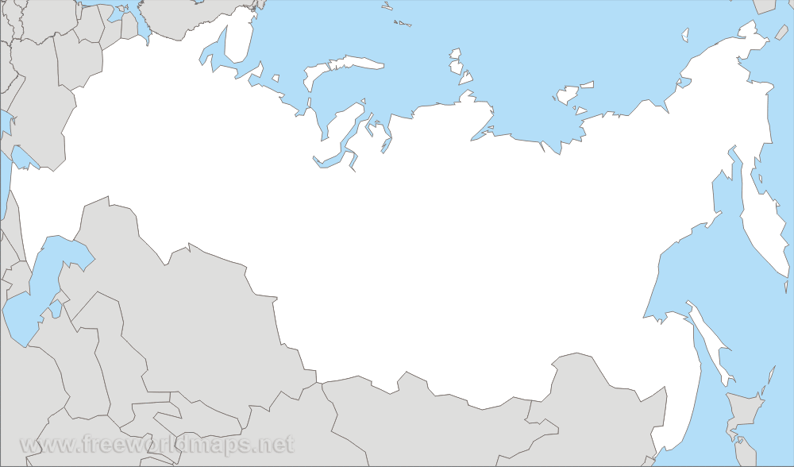

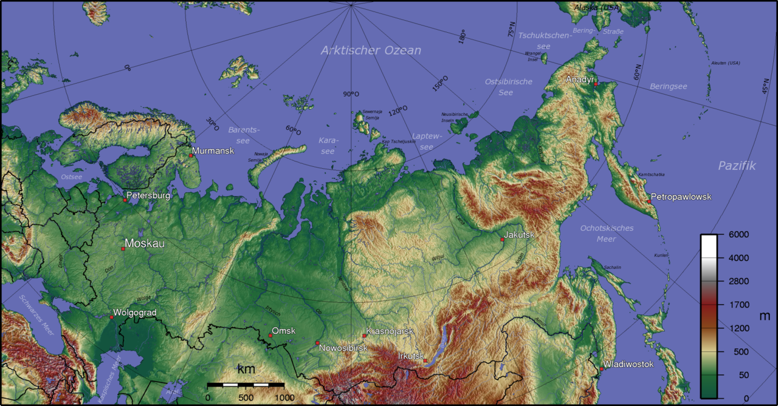
Students should annotate and add scale and north arrow to the outline map they are given. They may refer to an atlas. Note that because of the sheer size of Russia, it can appear differently depending upon the map projection used (compare above and below). This could be discussed with the class as an extension activity.

How does plate tectonic theory work?

Depending on whether or not students have studied plate tectonics, it may be necessary to explain plate movement from first principles. Good resources to assist their understanding include:

BBC Bitesize website: http://www.bbc.co.uk/bitesize/ks3/geography/physical_processes/plate_tectonics/revision/3/
The Geological Society website: http://www.geolsoc.org.uk/Plate-Tectonics
Slideshare website: http://www.slideshare.net/geographyalltheway/key-stage-3-geography-plate-boundaries-presentation

Plate tectonics is a scientific concept developed in the 1960s to explain the pattern of the Earth's land masses and the mechanisms by which they have changed position over time (its origins lie with Wegener’s theory of Continental Drift from 1912). Seven major crustal plates and twelve smaller plates have been recognised, each of which extends down into the earth’s upper mantle. These plates are thought to be moved by large scale thermal convection currents in the asthenosphere, generated by residual primary heat and radioactive decay in the Earth’s core.

Plates are composed of continental or oceanic crust or a combination of both (sial and sima, respectively). They are bounded by plate margins, which may be subdivided into four types:

(1) constructive margin, where new ocean floor is accumulated on either side of a mid-oceanic ridge
(2) destructive margin, where ocean floor is lost by engulfment along a subduction zone
(3) conservative margin, where plates move past each other laterally without adding or destroying ocean floor
(4) collision margin, where two continental plates collide. Neither plate is forced under the other, and so both are forced up and form fold mountains such as the Ural Mountains

See BBC Bitesize website: http://www.bbc.co.uk/bitesize/ks3/geography/physical_processes/plate_tectonics/revision/3/

Many of the Earth's major landforms can be explained by plate tectonics, especially mobile belts, island arcs and ocean trenches. Global patterns of earthquakes and volcanoes can also be explained through the hypothesis of sea-floor spreading, in which magma rises at the mid-oceanic ridges to form new crust which is moved laterally towards the plate margin, as if on a conveyor belt, where it is destroyed by subduction, or causes the ocean to increase in width (e.g. the Atlantic or the Red Sea). When the plate movements lead to the rate of construction being exceeded by that of destruction the ocean will begin to close (e.g. the Mediterranean).
Extension: how do we know?

The theory of plate tectonics only gained widespread acceptance after the 1960s, when the weight of evidence used to support it started to become very substantial

- Continental fit The east coast of South America and the west coast of Africa fit together with very few gaps.
- Common geology Rare Devonian violet quartzites are found in parts of Brazil and South Africa. These areas would have been adjacent when the two continents were joined.
- Flora and fauna fossil record Similar fossil remains may be found in both the Americas and in Africa and must therefore share a common descent; the distances separating them preclude migration as an explanation. For instance, remains of Lystrosaurus, a sheep-sized reptile that lived around 200 million years ago, are found throughout all of the southern continents.
- Palaeomagnetic explanation The earth’s magnetic polarity has reversed in the past and the parallel magnetic “striping” of sections of sea-floor either side of the mid-Atlantic ridge allows dates to be compared. The basaltic ocean floor also ages with increasing distance from the ridge in either direction, further suggesting that the floor is spreading apart.
- Ice Ages The northern limits of ice sheets extending from the South Pole for both continents during past ice ages broadly coincide. We would expect to see this if they were previously joined.

The Ural Mountains

The Ural Mountains extend about 2,500 km from the Arctic Circle to the grasslands of the northern border of Kazakhstan. The Urals are among the world's oldest mountain ranges, dated at 250 to 300 million years ago.
They were formed during the Uralian orogeny due to the collision of the eastern edge of the supercontinent Euramerica with Kazakhstania.

When did it all happen?

- Around a quarter of a billion years ago, all of the Earth’s land masses are thought to have been joined together in a single supercontinent named Pangaea. It was during the formation of Pangaea, when Euramerica collided with Kazakhstania that the Ural Mountains first developed.
- Pangaea later split into Gondwana (southern continents) and Laurasia (northern continents), anywhere between 200 and 135 million years ago. The date of the subsequent division of Africa and South America occurred later, but the exact date has remained a subject of much debate.
- Extracts one and two below provide an age-appropriate explanation of how and when the Ural Mountains were formed.

Extract one

The Ural Mountains run from north to south through Central Asia, separating Europe from Asia. Like the Appalachian Mountains (in the USA), the Ural Mountains formed about 300 million years ago, near the end of the Carboniferous period, when the first reptiles were evolving. This was when the tectonic plates began to form the supercontinent of Pangaea.

When the western Siberia plate smashed into the Baltica and North America plate, this action pushed up the land to make the Ural Mountains, and formed the supercontinent of Laurasia. But the Ural Mountains are not as eroded as the Appalachians; some of them still have glaciers at their tops all year round.

The Ural Mountains, together with the Appalachians, are among the oldest mountains in the world. They are far older than the Alps, the Himalayas, the Rockies, or even the Andes, which are the next oldest major mountains.

Source History for Kids website: http://scienceforkids.kidipede.com/geology/platetectonics/urals.htm

Extract two

Geologist estimate these mountains erupted 250 million years ago as one immense continent called the Euramerican continent powerfully collided with the smaller continent named Kazakhstania. After nearly 90 million years of one continent pushing vigorously against the other, majestic mountain peaks were forged into the landscape, with some eventually rising 6300 feet (1920 meters). Although these mountain peaks have eroded over time, they are still one of Russia’s – and the world’s – most awe-inspiring sights to behold.

Often referred to as the geographical dividing line separating Asia and Europe, the Urals provide the Russian Federation with a wealth of mineral resources as well as non-metallic substances consisting of talc, emeralds, fireclay (a material used in making ceramics), amethysts and topaz.

Ore deposits found in the Urals also hold rich amounts of copper, nickel, gold, bauxite, platinum and chromite. Additionally, natural gas and petroleum deposits lie in the Krasnokamsk and Ishimbay areas of the western Urals, where mining of lignite (a fuel predominantly used in operating steam-electric machinery) and coal occur year around on mountain slopes.

Source The Adventure Travel Writer website : http://www.adventuretravelwriter.com/history-of-the-urals-russia/

Ural Mountains timeline in pictures

280 million years ago  Early Permian period  Euramerica moves towards Kazakhstania | 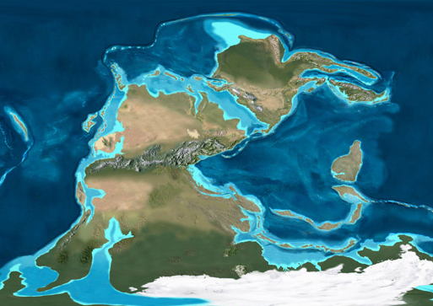
260 million years ago Late Permian period  Euramerica has almost reached Kazakhstania | 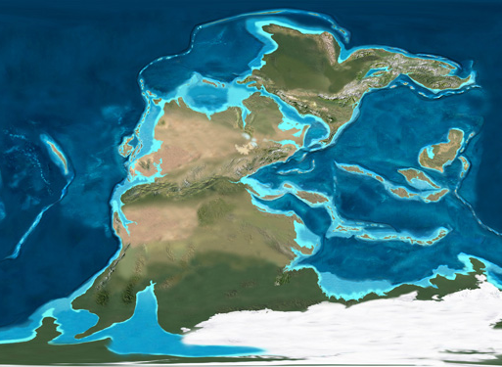
240 million years ago  Early to Middle Triassic  Euramerica collides with Kazakhstania and the Ural Mountains are created.  The Earth’s land masses form a supercontinent called Pangaea. | 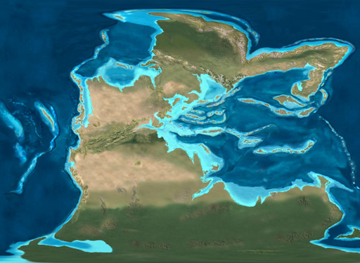
200 million years ago Early Jurassic  The supercontinent of Pangaea starts to break apart. | 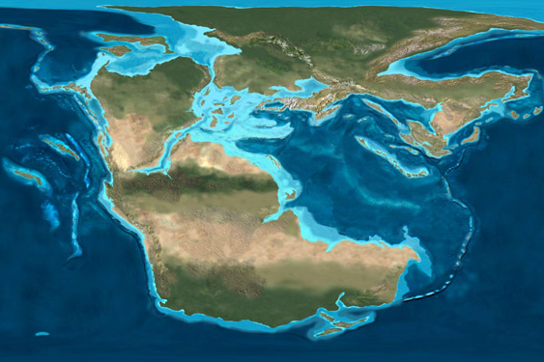
65 million years ago Tertiary-Cretaceous  Pangaea has broken into many pieces and the Atlantic Ocean has opened up. Sea levels are higher and the land east of the Urals has flooded | 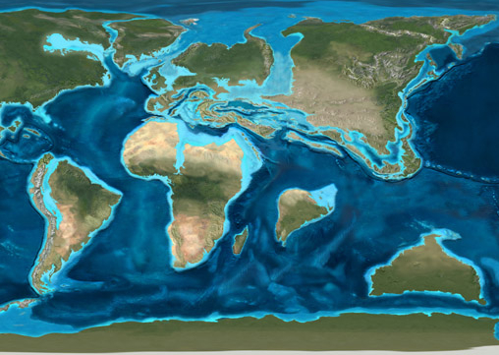
20 million years ago Miocene  Sea levels are lower again and the world is beginning to resemble what we see today | 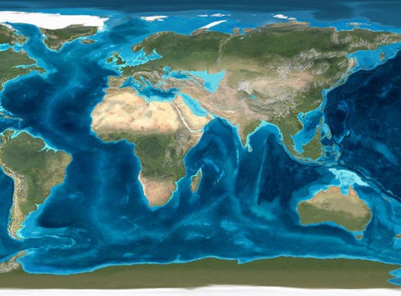

Ron Blakey, NAU Geology - http://cpgeosystems.com/mollglobe.html

Eurasia: a useful word to use when answering the question: ‘where is Russia?’

Eur (from Europe) + Asia = Eurasia

- Eurasia is the combined continental landmass of Europe and Asia.
- In some parts of the world, Eurasia is recognized as the largest of six continents.
- A term first used during the early 19th Century to describe two continents joined together in one land mass. Nearly half of the world’s 196 independent countries are in Eurasia. As of 2012, there are 93 independent countries in Eurasia. This includes all 48 countries of Europe, including the island countries of Cyprus, Iceland, Ireland, and the United Kingdom, 17 countries of the Middle East, 27 countries of Asia, including Indonesia, Malaysia, Japan, Philippines and Taiwan.
- Eurasia has roughly 70 per cent of the world’s population, or 5 billion people. This includes about 4.2 billion people in Asia and 740 million people in Europe. The remainder of the world's population lives in Africa, North and South America, and Oceania.
- A land mass of 52,990,000 square kilometres.
- Europe and Asia are divided by the Ural Mountains.

To find out more go to the Geography About.Com website: http://geography.about.com/od/learnabouttheearth/a/What-Is-Eurasia.htm

