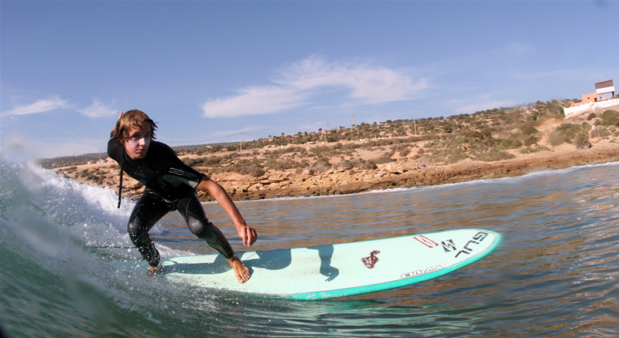
How does climate change affect this surfer?

Ben Haworth is the British Junior long board champion and is currently ranked no. 2 in Europe. How does climate change affect this surfer? Here are some possible positive and negative effects.

Possible negative effects:
- Sea level rise: loss of beach side properties
- Equipment: surfboards are made of toxic materials
- More hurricanes: increased damage to property and risk to life
- Warmer waters: more shark attacks?
- Getting to the beach: foreign travel creates carbon emissions

Possible positive effects:
- Sea level rise: creation of new waves
- Equipment: sustainable surfboards are becoming available
- More hurricanes: create more waves
- Warmer waters: less need for a wet suit

