Feelings about your environment

Area 1  -------------------------------------- |  |  | 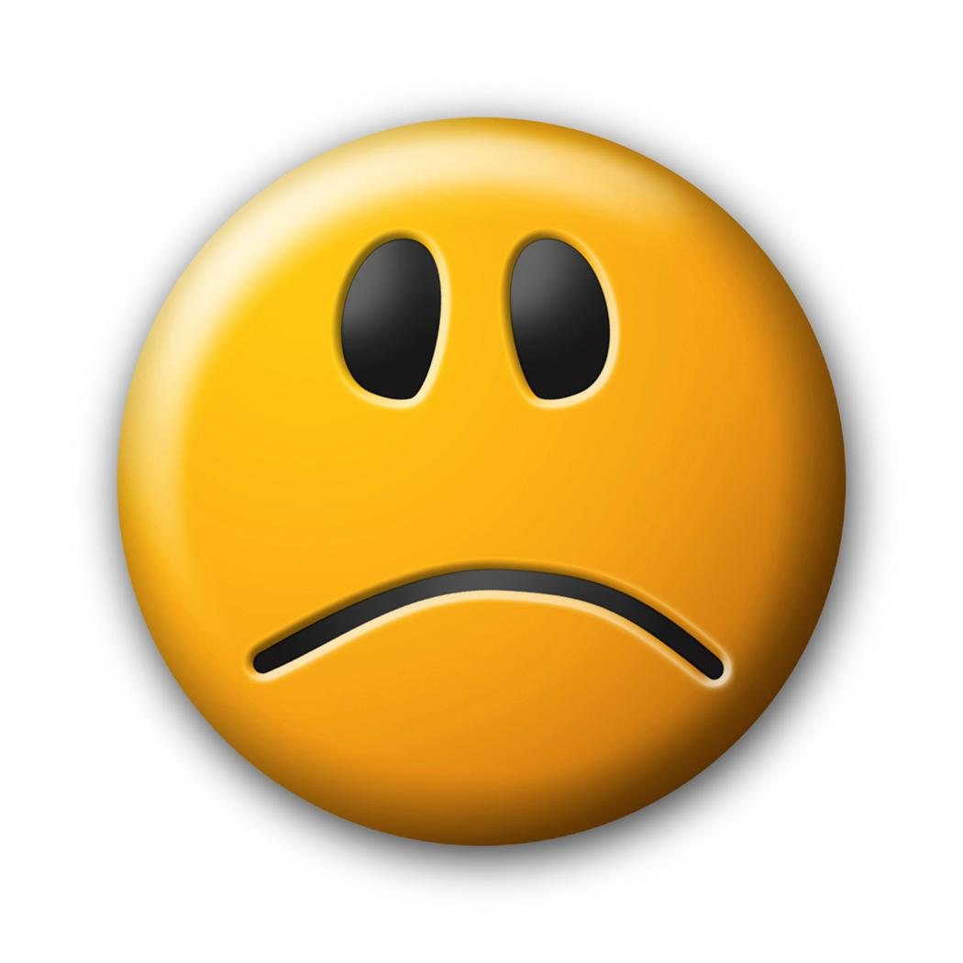
How do you feel?
Is the area tidy?
Is the area quiet?
Do you feel safe?

Area 2

--------------------------------------
How do you feel?
Is the area tidy?
Is the area quiet?
Do you feel safe?
Area 3

--------------------------------------
How do you feel?
Is the area tidy?
Is the area quiet?
Do you feel safe?

Area 4

--------------------------------------
How do you feel?
Is the area tidy?
Is the area quiet?
Do you feel safe?

Area 5

-------------------------------------
How do you feel?
Is the area tidy?
Is the area quiet?
Do you feel safe?

