Above and below

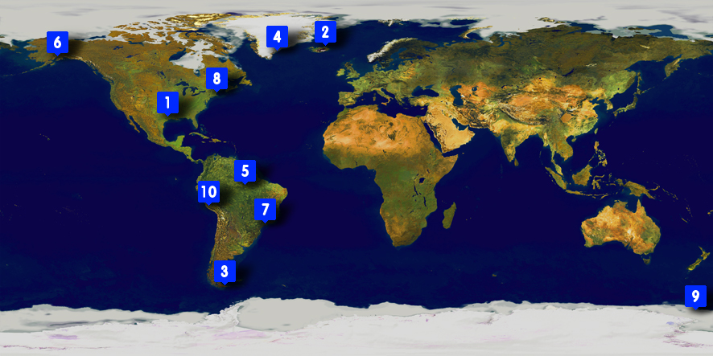
On this page you can see ten photos taken from high in the air. Each of these matches up with one of the places marked on the satellite image of the world shown on page one.
On the following pages you can see these photos in more detail.
Can you work out which photo goes goes with which marker on the satellite image?
You could use an atlas to help you

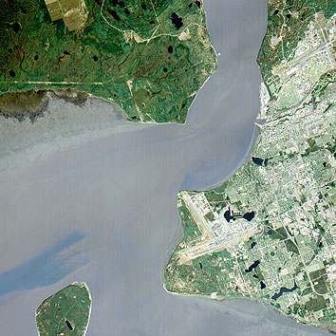 | 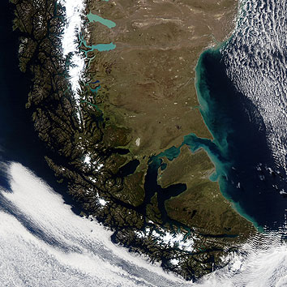 | 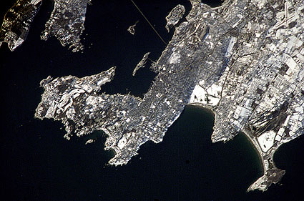 | 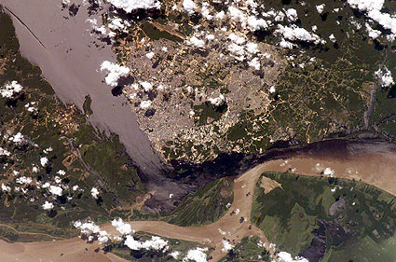
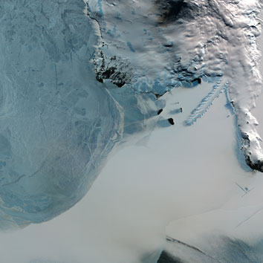 | 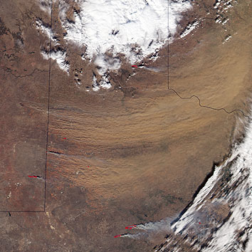 | 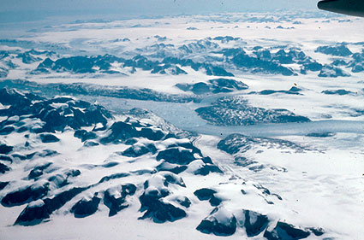 | 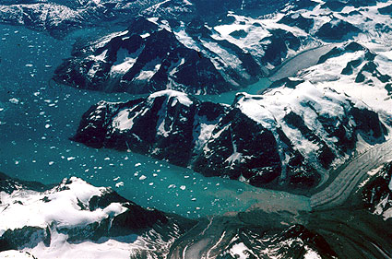
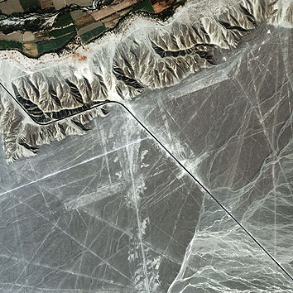 | 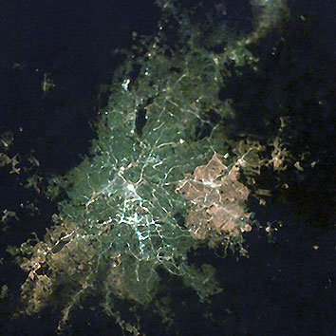

Picture 1 goes with marker | Picture 2 goes with marker
Picture 3 goes with marker | Picture 4 goes with marker
Picture 5 goes with marker | Picture 6 goes with marker
Picture 7 goes with marker | Picture 8 goes with marker
Picture 9 goes with marker | Picture 10 goes with marker

Answers
photo 1 is of Anchorage in Alaska – it goes with marker 6
photo 2 is of Tierra del Fuego and Ushuaia - it goes with marker 3
photo 3 is of Newport Rhode Island in the USA - it goes with marker 8
photo 4 is taken near Manaus in Brazil - it goes with marker 5
photo 5 is of a glacier in Antarctica - it goes with marker 9
photo 6 is of a dust storm in Texas, USA - it goes with marker 1
photo 7 is taken above Eastern Greenland - it goes with marker 4
photo 8 is taken above Iceland - it goes with marker 2
photo 9 is of the Nazca Lines in Peru - it goes with marker 10
photo 10 is of Sao Paolo in Brazil - it goes with marker 7

