Views of Partition

Two new countries were created after the end of British rule in India in August 1947. Punjab was divided to create West Pakistan and Bengal was divided to form East Pakistan. In 1971 East Pakistan separated to become Bangladesh.
The break-up of India along religious lines resulted in the movement of about 14.5 million people - Muslims going to Pakistan from India and Hindus and Sikhs going in the opposite direction.
The newly formed governments were not equipped to deal with such a massive migration - one of the largest of its kind in the world - and there was huge violence on both sides of the border.
The upheaval resulted in a breakdown of law and order: estimates of casualties vary, from between 200,000 up to a million people. Around 12 million people were left homeless and thousands were raped.
Different views
There have been many books written about the partition from different historians, both British and Indian. Many of these have focused on the main politicians and political leaders of the time involved in making decisions. These accounts have drawn on primary sources such as official government records and private papers of people.
Some historians have suggested that Britain was forced to act speedily because of the breakdown of law and order, and that matters would have got worse the longer they remained. It was also argued at the time that Britain had limited resources after World War II.
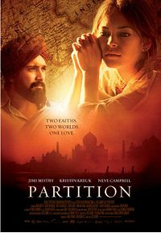
However, others have accused Britain of pulling out of India too quickly. Critics say that they failed to come up with a proper map of the border, and failed to plan for the huge migration.

Recent studies have begun to focus on people’s experiences and perceptions of the partition, in particular the massive violence that surrounded it. Some historians have compared the experiences of different groups of people through interviews.

Other important sources that historians have used to explore partition are books and films. These often show the hidden stories of violence and the voices that are often not heard in official histories.

Who were the leaders?
Jawaharlal Nehru (1889-1964) was an Indian nationalist leader and statesman who became the first prime minister of independent India in 1947. He studied law in England, then returned to India in 1912 and practised law for some years. In 1916 Nehru joined the Indian National Congress which was fighting for greater freedom from the British. He was heavily influenced by the organisation's leader Mohandas Gandhi. During the 1920s and 1930s Nehru was repeatedly imprisoned by the British for civil disobedience. In 1928, he was elected president of the Congress and played a central role in discussions over Indian independence.
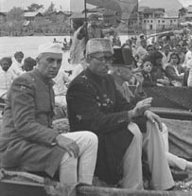

Nehru (left) in Srinagar, 1950

Mohandas K Gandhi (1869-1948) was known as 'Mahatma' (great soul), and was the leader of the Indian nationalist movement against British rule. His ideas of non-violent protest to achieve political and social progress has been hugely influential throughout the world.
He trained in London as a barrister and worked in South Africa for many years where he was appalled by the treatment of Indian immigrants there, and joined the struggle to obtain basic rights for them. In India, Gandhi transformed the Indian National Congress, and his programme of peaceful non-cooperation with the British included boycotts of British goods and institutions, leading to arrests of thousands. Gandhi was opposed to partition, and fasted in an attempt to bring peace and calm to the cities. On 30 January 1948, he was assassinated in Delhi by a Hindu fanatic.

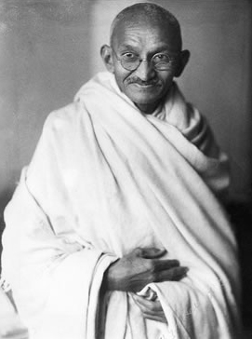

Gandhi in India, 1931

Mohammad Ali Jinnah (1876-1948) was an Indian politician who successfully campaigned for an independent Pakistan and became its first leader. He is known as 'Quaid-I Azam' or 'Great Leader'. He also studied law in London, before working in Bombay, India. He joined the Indian National Congress, but left to fight for an independent Pakistan for the newly formed Muslim League. Jinnah had always believed that Hindu-Muslim unity was possible, but reluctantly came to the view that partition was necessary to safeguard the rights of Indian Muslims. Jinnah became the first governor general of Pakistan, but died of tuberculosis on 11 September 1948.
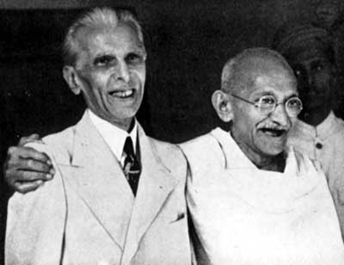

Jinnah (left) with Gandhi in Bombay (Mumbai),
September, 1944

Lord Louis Mountbatten (1900-1979) was a grandson of Queen Victoria. He was a British naval officer and was the last viceroy of British India and first governor general of independent India.
In March 1947, Mountbatten became viceroy of India to oversee the British withdrawal. He established good relations with leading politicians, particularly with Jawaharlal Nehru, but was unable to persuade the Muslim leader Mohammad Ali Jinnah of the benefits of a united, independent India.
Mountbatten soon gave up hope of a united country and on 14-15 August 1947, British India was partitioned into the new states of India and Pakistan.

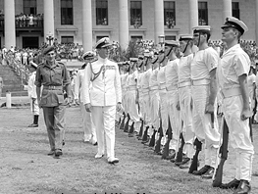

Lord Mountbatten in Singapore, 1945

Countdown to Partition

Date | Event
1858 | India comes under direct rule of the British crown after failed Indian mutiny
1885 | Indian National Congress formed
1906 | Muslim League formed to safeguard Muslim interests
1920 | Nationalist figurehead Mahatma Gandhi launches anti-British civil disobedience campaign
1930 | Alama Iqbal proposes the two-nation theory
1933 | Then name Pakistan is proposed
1940 | Jinnah calls for a separate Muslim state
1942-43 | Congress launches "Quit India" movement
1943 | Muslim League supports “Divide and Quit! plan
June 1947 | Mountbatten Partition Plan approved
July 1947 | India Independence Act passed in Britain
August 15 1947 | Separate states of Pakistan and India are created
1947-48 | Hundreds of thousands die in widespread communal bloodshed after partition

Source: http://news.bbc.co.uk/1/hi/world/south_asia/1155813.stm

Audio-visual footage

Mountbatten
http://news.bbc.co.uk/player/nol/newsid_6930000/newsid_6937600/6937650.stm?bw=bb&mp=wm&asb=1&news=1&bbcws=1

Nehru
http://news.bbc.co.uk/player/nol/newsid_6930000/newsid_6937600/6937642.stm?bw=bb&mp=wm&asb=1&news=1&bbcws=1

Jinnah
http://news.bbc.co.uk/player/nol/newsid_6930000/newsid_6937600/6937601.stm?bw=bb&mp=wm&asb=1&news=1&bbcws=1

Photographs of Partition

http://news.bbc.co.uk/cbbcnews/hi/newsid_6940000/newsid_6947200/6947269.stm

People’s experiences

http://www.throughmyeyes.org.uk/server/show/nav.22173

Contemporary Films

Partition (2007)
http://www.imdb.com/video/screenplay/vi514785561/

Earth (1998)
http://www.imdb.com/video/screenplay/vi1956905241/

