Lesson Three: Perplexing Poles
Factsheet for teachers

- What does ‘Antarctica’ mean?
- What seasons are there on this continent?
- What is life like at the Poles?
- What time of year would you plan your expedition?

Location
Antarctica is at the opposite end of the earth from the Arctic. It is the Antipode of the Arctic so it is ant-arctic. The word Antarctica is based on the Greek word for bear: Arctos. Arctos is the name of a constellation visible from the northern hemisphere. The northern polar region is named Arctic, after Arctos. In advance of understanding the mysteries of the opposite polar region, they named it anyway, as opposite of Arctic or Anti-Arktos, which evolved into Antarctic, the region and Antarctica, the name of the continent.

Seasons in Antarctica

There are two seasons in Antarctica – these are summer and winter:

- Winter occurs from June 21 to December 21
- Summer occurs from December 21 to June 21

The winters are cold and there is very little sunlight. The summers are warmer than the winters, but have a lot of sunlight hours, but the temperatures still remain low. At the South Pole, there is just one period of daylight each year, and it lasts for six months! The other six months of the year are dark because the sun does not come above the horizon. This is because the Earth is tilted and curved, so the sun doesn't shine as strongly onto the poles as it does at the Equator. Of the sunlight that does reach Antarctica, about 90%-95% of it bounces off again because ice is an excellent reflector of sunlight. This means that only about 5%-10% of the solar energy is available for warming. (As a comparison: grasslands reflect 30%-40% and a conifer forest 10%-15%). Antarctica is the world's largest desert because it has so little rain and very little grows there.

Weather in Antarctica

Antarctica is the coldest place in the world. The coldest temperature ever recorded was at the South Pole where it was minus 88ºC (88º below 0º). The winds in Antarctica reach over 300 km an hour; the most severe winds being the katabatic winds. Antarctica is also very dry with only 4cm of rain falling each year in the form of snow (this is less than the Sahara Desert).

Working in Antarctica

Scientists work in Antarctica because it is an important place. The Antarctic ice sheet is over 70% of Earth's fresh water and about 90% of Earth's ice. If it melted, the world's sea level would rise about 70 metres. Cold water, full of oxygen, originates in Antarctica and flows out into the other oceans, helping circulate and refresh ocean waters. The sea surrounding Antarctica is home to marine life from tiny algae to huge whales. Scientists are trying to find out how Antarctica responds to environmental change, which will help them better predict how the rest of Earth will respond to future environmental changes.
People who go to Antarctica must learn many survival skills.

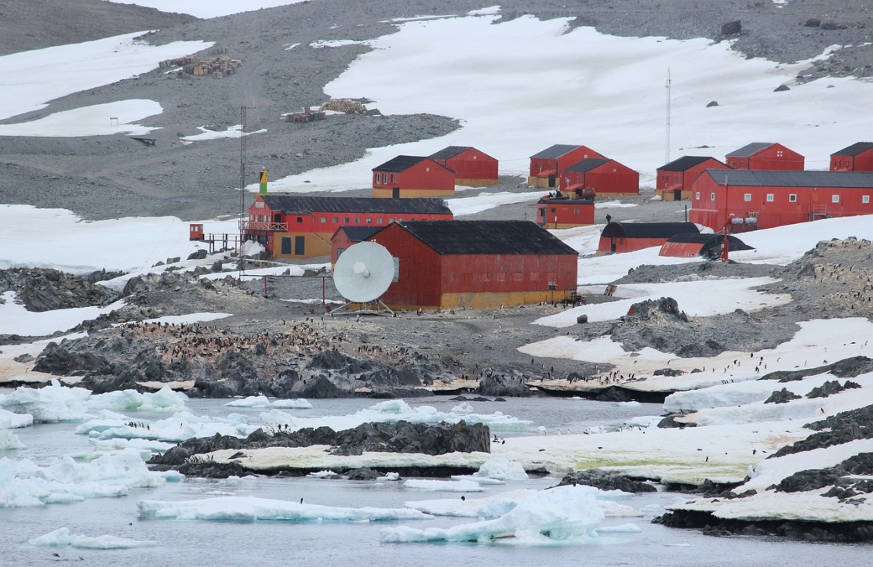
Argentinian Station in Antarctica © Pixabay, Mariamichelle

Special housing is necessary because of the extreme cold and incredible winds that can blast the continent. There are 'melon' and 'apple' huts which are able to be anchored firmly and kept warm. Special clothing and equipment is necessary, and all members of the team must learn some medical skills in case of emergencies. They must learn how to deal with different conditions that may arise, such as 'whiteout' which can occur at any time, when people can hardly see their hand in front of their face. People can easily become lost even if they are close to shelter.

In summer, tourists can now make brief visits to see Antarctica. Passenger ships sail all around the continent and anchor off the coast. Smaller boats take people from their ship to land, where they can enjoy guided walks. Some huts of the early explorers have been preserved and can be visited. Planes sometimes fly over Antarctica so people can see it from the air. Go to the Discovering Antarctica Website: http://www.discoveringantarctica.org.uk

