Glacier image annotation task

Study the photograph below of a small cirque glacier in Washington State, USA, taken in July.
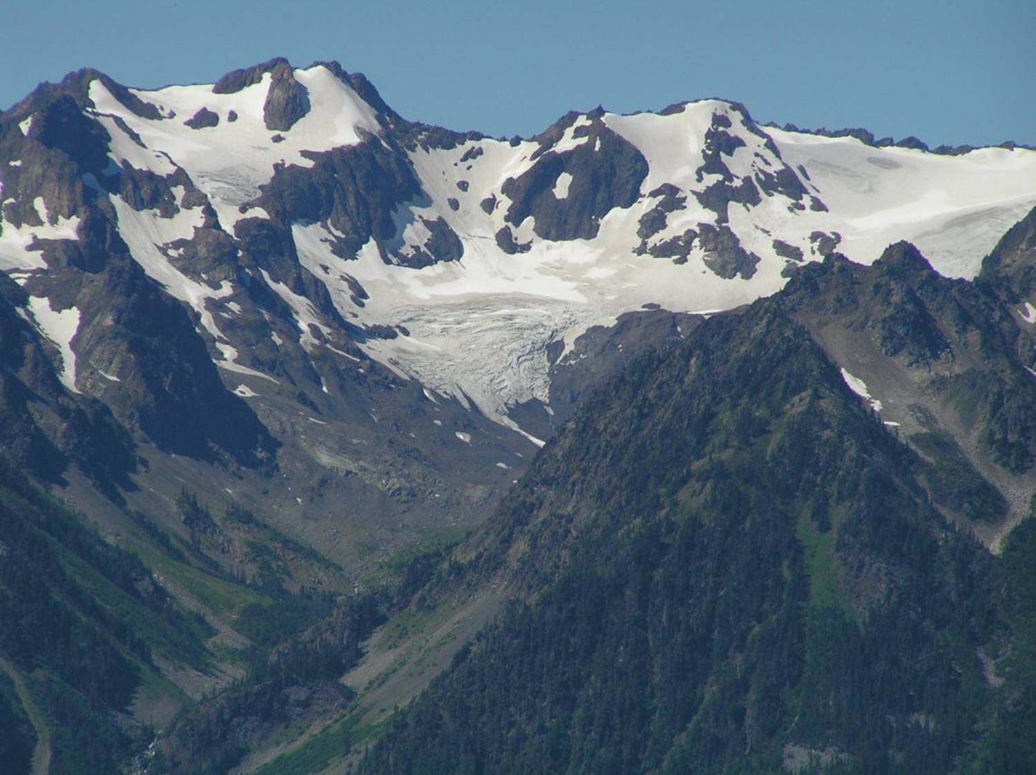
Equilibrium line
Accumulation zone
Ablation zone
Glacier terminus
Now label in the same features shown above in this generalised drawing of an alpine valley glacier in summer. Also label the area of the glacier that is called the ‘snout’ and the surrounding ‘moraine’.
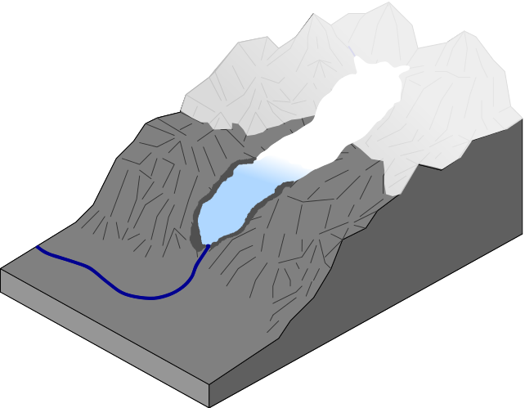
http://commons.wikimedia.org/wiki/File:Image_Valley_Glacier.svg
Would the type of glacier in this diagram be likely to flow relatively fast or slow? For what reasons?
Now study this aerial photo showing part of a glacier in Antarctica. With a pencil, draw a simple sketch of the photograph in the box below it. On your sketch, label the following:
- Glacier terminus, ice shelf, icebergs, crevasses
- Also draw in lines with arrows to indicate the apparent flow direction of the ice.
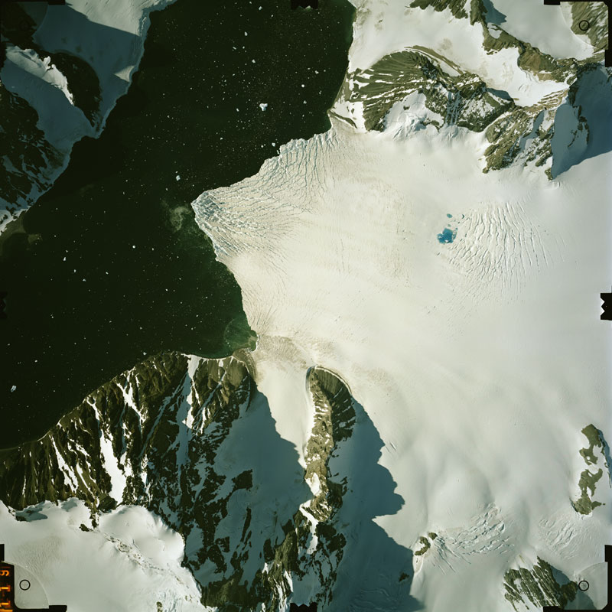
[Image 4 in Aerial Photography Picture Gallery BAS, Antarctic Peninsula]
For scale - the icebergs floating in the water are larger than boats.

Further questions:
In contrast with the images of alpine glaciers on the previous page, how is the process of ablation different for this Antarctic glacier?
Can you suggest reasons for why the crevasses are located where they are on this glacier?
Further into the interior of the Antarctic ice sheet, how does the climate compare with the climate in the mountain area shown on the previous page?
Looking back at the photo of the cirque glacier, can you suggest why the ablation zone of a glacier looks darker than the accumulation zone?

