Bushfires in Australia
What is a bushfire?
A bushfire is a fire in a forest that spreads rapidly. Australia is at high risk of bushfires because of its climate and landscape.
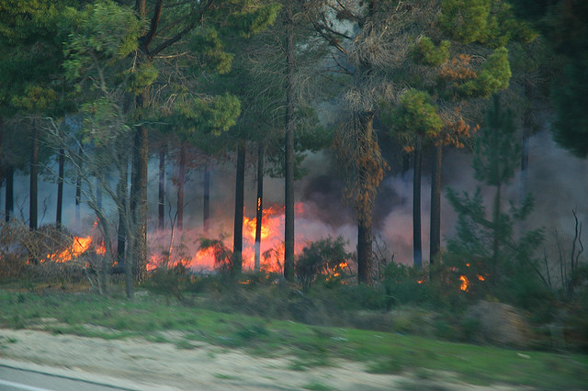
Australia’s hot climate and dry landscape mean bushfires happen every year in Australia. During heat waves and drought, the dry forest can set alight and can spread quickly.
There are two types of bushfire:
- Mountainous fires: when a fire starts in a mountainous area covered in forest. The steep terrain can make the fire more difficult to put out.
- Grassland fires: when a fire spreads across flatter land. Although this type of bushfire is easily spread by the wind, they are easier to put out.
Bushfires ©bertknot, Flickr

How to stay safe
- Only grow plants that cannot catch on fire to protect your home and land.
- Follow the rules and make sure your home is as safe as possible and well-protected in case of a fire. The safest homes are an oval shape.
- Create barriers around your house and remove any flammable materials like barbeques and gas.
- Close any open spaces so fires cannot spread.
- Keep all fallen trees off your property and dead shrubs, clean gutters and remove debris from the roof of your home.
- Keep facemasks and fire sheets at home in case of heavy smoke and fires indoors.
Case Study: The Black Saturday Bushfires
In 2009 Australia experienced some of the deadliest bushfires ever, the ‘Black Saturday Bushfires’. The fires burnt through the state of Victoria, and over 400 different fires were recorded. Unfortunately 173 people were killed and over 400 people were injured, around 2,000 homes were destroyed.
The emergency services battled with the flames from Wednesday until they finally calmed down by Monday. The Australian fire services had 433 firefighters on site.

Areas most affected by bushfires
