
Dendrochronology exercise

- Obtain a transverse section of wood. This can be a log, a core or a section. It needs to include the outside section (bark) but does not need to go to the centre. If it does not go to the centre you will need an approximate value for the original radius of the tree.

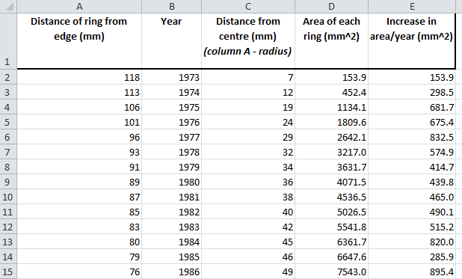
- From the outside measure the distance of each ring from the edge to the nearest mm, make sure you stick to the same point of reference on a ring as you move inwards. Tabulate the data in excel (Column A on Figure 1 below).

Figure 1: example of data

- Identify your rows with the year putting with the most recent year at the top (Column B). This will be the year the tree was cut down if you know this date.

- Reverse the column order so the oldest year is at the top and the youngest at the bottom (the easiest way to do this is to sort the data from smallest to largest on the year column)

- Insert a column (Column C) of the distance of each ring from the centre of the tree, in other words the radius of that years ring. To do this, subtract the radius of the whole section from the distance of each ring from the outer edge of the section (Column A).

- Calculate the total area described by each ring (Column D). Use πr² where r is the ring radius calculated in column C.

- In column E, subtract the areas of each year from the previous to give the increase in area per year

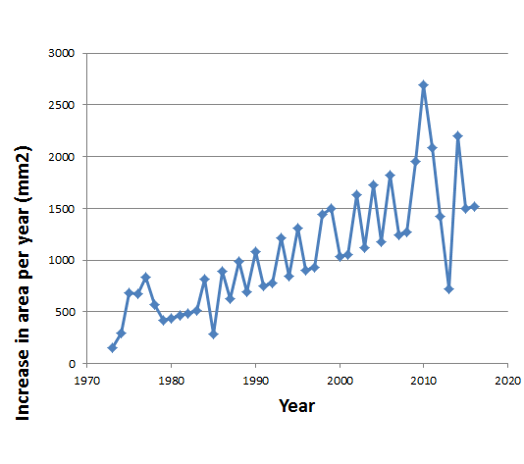
- You can now plot yearly change in ring area (Column D) over time (Column B) (see Figure 2)
Figure 2: plot of year change in ring area

These resources were produced by BIFoR as part of a CPD event held at the University of Birmingham in February 2017.

