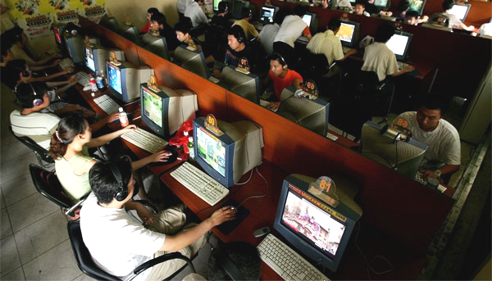
Tackling the Digital Divide

A digital divide exists between people who have access to the internet (and other forms of digital communication) and those who do not. The divide can be either social or spatial in nature (and often the two are inter-related). Efforts are underway in the UK to tackle both types of inequality.

oday in the UK, around 30% of all
homes lack any kind of access to
ICT. As many as 10 million British citizens have never been online and of these four million are classified as "highly disadvantaged" individuals. A large proportion are aged 65 and over. Why is this even an issue? Because the evidence suggests that:
- A typical family can save £560 each year making use of online services that include cheap purchasing of goods (e.g. of children's books at Amazon) and services (e.g. cheap advance booking of railway tickets).
- People can find work opportunities with online searching.
- Socially isolated people can make friends and build a support network for themselves as part of an online community.
One study has also suggested that the UK government would save nearly one billion pounds every year if each of Britain's 10 million non-users of the internet made greater use of local government e-services.
It is not just a question of either “having" or "not having" access to digital communications technology that determines the level of digital inequality found in a society or place. A more subtle digital divide also exists between people who are dependent on un-metered (“always-on”) technologies and metered, "pay-as-you-go" or battery-dependent technology. Payment options must therefore also be considered in addition to the more fundamental conception of a divide between "haves" and "have-nots" across a wide range of possible access modes.

Tackling social digital exclusion

Some people suffer from involuntary social exclusion (Figure 1). The elderly, the infirm and the blind may not be able to interface effectively with computer keyboards, email or text messaging systems, for instance. There also remain barriers to education in ICT, such as lack of English reading skills, and “technophobia” (39% of retirees do not use the internet; and the figure rises much higher for those without good educational qualifications).

Keywords

Digital divide Some people do not have the means to access online information and services. A further distinction can be made between people who have access to fast broadband internet services; and those who use less reliable and slower dial-up services using a computer modem.
T

Rebranding Developing a place to reposition its image and change people’s perception of it; helping sell a place’s tourism services to a new target audience.

Local champions Key local players who are involved in bottom-up efforts to attract top-down investment to a place. The actions of local champions have been crucial in securing broadband investment by BT for remote rural areas.

Where people have an irrational fear of finding the internet “too hard” to use, research suggests that this fear is best tackled through the provision of peer-to-peer assistance (when the training is
provided by people’s local friends rather than experts).
There are also additional barriers to computer use for learners who are visually or hearing impaired. However, specialist adaptive hardware and software is now available (although the additional costs may have to be borne by the consumer).
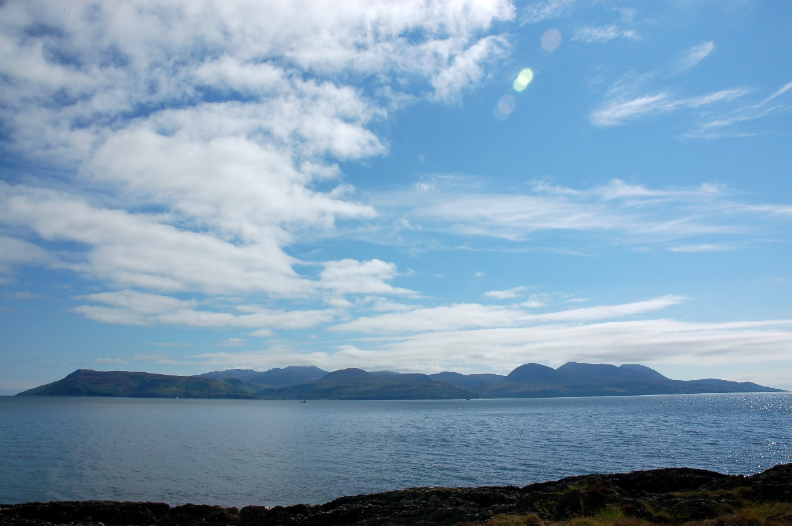
Of course, it does not automatically follow that new technologies will be willingly adopted by potential users. Some people will always remain voluntarily excluded. Several million of the British population – across all age groups - may well be exercising their choice not to use the internet, even though they have home, work or shared facility access (Table 1).
Photograph 1 Isolated, hard-to-reach islands lie off Scotland’s coast

Bridging the nation’s rural-urban divide

Digital Subscriber Line (DSL) broadband technology has recently revolutionised access to telecommunications services. In the 1990s and early noughties, many homes gained internet access using a dial-up modem. Data speeds were typically limited to 33 KB/s (meaning it took around one minute to download a large photograph). With broadband technology, speeds of between 100 and 1000 time faster (i.e. reaching several MB/s data download speeds) are now quite common. Note that the UK is ranked as a “slower” nation overall (with an average advertised 10 MB/s compared with rates of 80 MB/s in South Korea and even higher in Japan)
High broadband bandwidths allow for a range of applications to be used by people. Particular applications which rely on high quality video images include TV “on demand” applications such as BBC's iPlayer. The BBC and BT are currently working together on Project Canvas which they hope will bring TV into people’s living rooms via the internet in the future. Broadband access is essential for this.

Uneven geography

Access to broadband services in remoter rural areas of the UK is still patchy. Access for homes is dependent on British Telecom (BT) fitting out its local exchanges to support fast broadband services. Economies of scale mean that DSL upgrades for many local exchanges in remoter areas will never be fully commercially viable, and that some degree of state aid assistance is needed. This is a worry for areas where tourist rebranding schemes are required or where more counterurban migration needs to be encouraged to offset youthful out-migration.
BT originally set its targets to be as low as 150-200 users in some rural community areas before the service would become commercially viable. When this target is not met, a variety of government initiatives exist to help bring broadband to such areas. At the start of 2010, the government was even planning to tax all UK households 50p per month to help pay for universal broadband. However, a “broadband tax” may not be supported by the new 2010 parliament.
Figure 1 There are many reasons why
10 million UK citizens were not yet online in 2010
Even with government financial assistance, deployment of DSL broadband technologies may still be constrained by technical matters in some very remote rural locations, especially isolated islands or peninsulas (Photograph 1). In the UK, for example, only 70% to 90% of rural lines are actually capable of delivering the kinds of high-speed broadband data transfer rate found in major urban areas. This is because the final journey that internet data makes into people’s homes uses the copper telephone wire that runs from a street cabinet (Photograph 2). In some cases the copper wire is not able to carry a large amount of data, even in some urban areas. The ideal situation would be to run a high speed fibre optic cable direct to everyone’s homes – but this would be extremely expensive to do.
Wireless internet options do exist for very remote communities. 3G higher spectrums (principally 26–28 GHz and potentially 40 GHz in the UK) can easily package voice and data in its delivery. Coverage per base station at 28 GHz is around 13 square kilometres and bandwidth of up to 11 MB/s can be provided. Even with this technology, broadband wireless solutions will not be technically suitable for all locations, depending on the local topography. The key requirement for WiFi technology is for (near) line-of-sight access from the customer to the base station.
Access mode | Key issues
Home access | Household penetration by the internet now stands at 67% . However, this figure conceals more than it reveals. Data transfer capability and frequency of use vary greatly between households. Amongst Britain’s elderly, 39% of over-65s lack access. Also, some 3 million homes have a broadband service the government thinks is too low (lower than 2 MB/sec).
Community shared access | The prohibitively high cost of computing in the 1990s led to a “kiosk” model of local access gaining popularity with local government and enterprise companies. Enthusiastic promotion of telecottages in the Highlands and Islands was followed by support for village hall internet terminals. Libraries have played a key role as local providers. Schools are an important place for children from low-income families to gain internet experience.
Mobile phone and laptop access | Most of the UK’s adult population now uses a mobile phone. However, the figure is much lower for the most elderly cohorts, while studies show that many people limit usage to reduce costs by sticking to pre-pay options and often turning their phones off. “Pay-as-you-go” customers are less likely to use their mobiles to gain internet access (or pick up emails). Note that mobile broadband is becoming an important way of getting fast internet access into rural areas that lack a good landline service.
Work access | Nearly all small businesses are likely to have broadband and are "always-on" organisations that are easily contactable by email during business hours. But some businesses in remoter rural areas may still be less likely to have access to broadband which their employees can use for personal reasons during breaks or after work.
“Proxy access” | A typical non-user of the internet is aged over-50. However, such individuals often ask others to act as a “proxy user” if they have a good reason (perhaps asking their children to work the technology). Survey data show that 6% of non-users have had someone make a purchase online on their behalf, 7% to send an email and 13% to find information.

Table 1 Internet access points for people and communities
Other options for digital delivery include:
- Mobile services The potential for the delivery of effective internet access using this service is high given that most of the adult population possess a mobile. However, many lower-income users may not be able to afford a mobile internet service, preferring simple pay-as-you-go options for calls and texts only.
- Digital television and radio The majority of households have adopted a digital television through which they receive programming delivered by a cable television network, a satellite receiver or free-to-air broadcast. Both satellite and free-to-air systems currently provide interactivity within the system. However, the data being transmitted on the back channel is currently low volume, comprising simply of command and information requests. In the future this is likely to improve though.

Fostering even greater rural access

Where access to new ICT media remains low (either socially or geographically), how might greater uptake be fostered ahead of market forces? There are various strategies employed by branches of central and local government and NGOs to drive uptake and these include:
- Taskforce campaigning There is no shortage of schemes currently underway to foster greater uptake of both internet and more specifically broadband technology. The UK Broadband Taskforce set up by the DTI and OGC (Office of Government Commerce) aims to help central government honour its commitment to deliver a much wider variety online services. Wired-up Communities (WuC) was launched back in 2000 by what is now DCFS with £10m funding to investigate how the digital divide could be bridged by enabling communities to use ICTs to access jobs, learning services, government and other services. Today, the Digital Inclusion initiative plays a big role. The government aims to have the whole nation online by 2012!
- Local champions Canvassing for broadband at a grassroots level has brought great success in some remoter / low population density regions. In 2003, BT upgraded internet services in some rural areas after “grass-roots” demand was demonstrated (Todmorden was the first, after 200 locals registered interest).

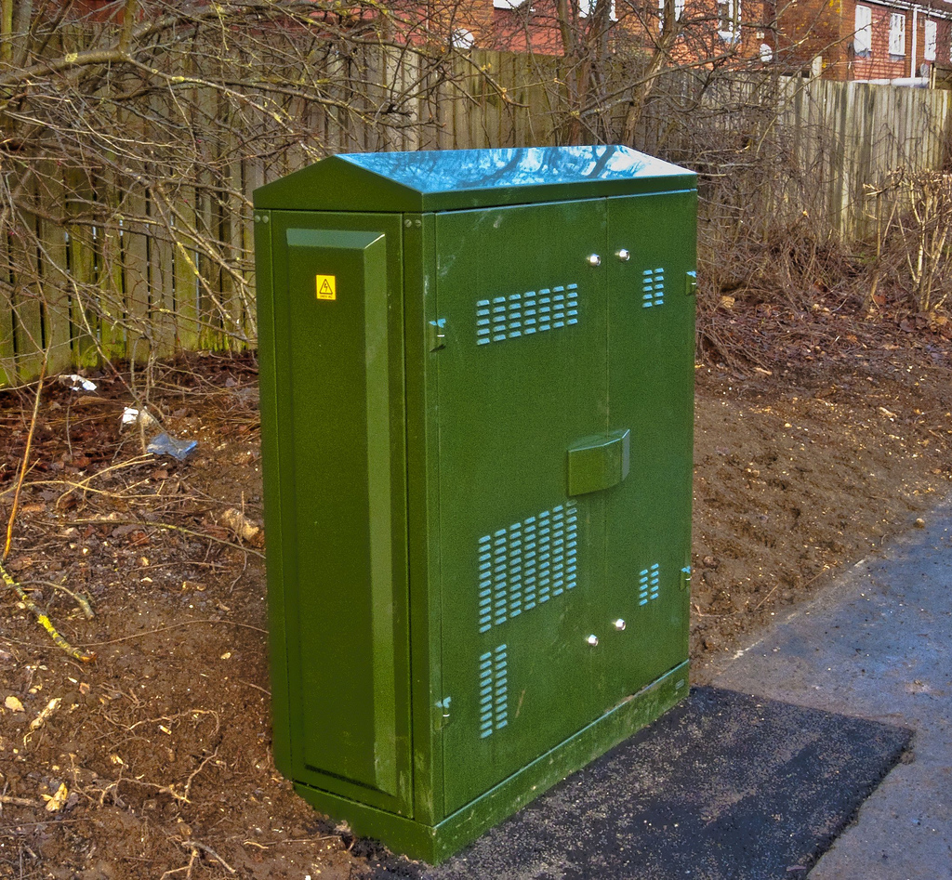

Photograph 2 Date is transmitted at super-fast speeds to street cabinets before moving more slowly into homes along copper wires

Key points

- There are two types of digital divide: the social (income) divide and the geographical (rural-urban) divide.
- The digital divide is important because fast broadband internet offers multiple ways to increase people’s quality of life (and people who are not online may not realise this).
- The UK government hopes to overcome the social digital divide through education and initiatives such as the Broadband Taskforce.
- The rural-urban digital divide can only be overcome through large-scale investment, possibly using money raised through taxes.
- There are several possible ways of increasing rural internet access, for instance through greater use of wireless technology.

Written by Simon Oakes. Images (c) TimYang.Net, S. Oakes (Photograph 1) and Flickr user: Mike Cattell (Photograph 2).

