More Information…
About Landslide Management

Landslide management is concerned with reducing the effect of landslides for the benefit of settlements, populations and ecosystems. Management techniques can be split into hard engineering (man-made structures) and soft engineering (conceptual or natural practices). No single method represents a perfect reaction to the problem of landslides as each slope presents unique characteristics that require individual analysis and management.

Hard Engineering Techniques generally fall into four categories (Figure 1).
Some examples of hard engineering techniques:
Changing the shape of the slope
e.g. removing rocks
Changing the amount of water in the slope
e.g. drainage
Protecting people and the built environment
e.g. fencing
Increasing the strength of the slope
e.g. anchoring
Figure 1: Categorising hard engineering techniques
Anchorage This is where large metal bolts and or anchors are driven into the slope to reinforce it. Compared to other methods, anchorage can be quick to complete and relatively easy to engineer. However unless the bolts are placed under tension, the anchor has limited strength and in most cases will only work with hard rock, as the bolts will slowly ease themselves out of softer rocks.
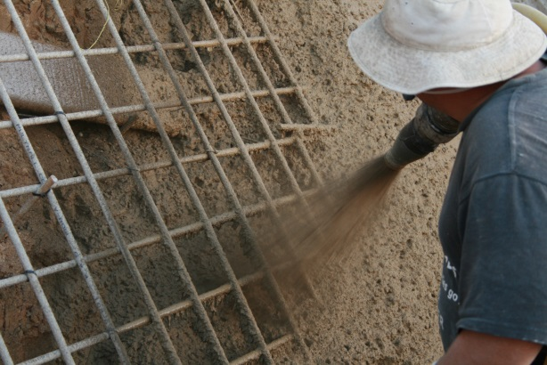
Shotcreting A concrete mix is blasted at high speeds onto a slope surface (Figure 2) in order to stabilise any loose material there. While this is a cheap method to deploy, it can also lead to heavier rock faces if sprayed onto the wrong surface, creating a greater landslide than if no measure had been taken.
Figure 2: Shotcreting a slope (Source: Flickr Creative Commons user Inconmat)

Drainage By reducing the amount of water held in a slope, the weight and vertical pressure of possible material reduces and the chance of a large slip plane forming is reduced. As well as building drainage ditches into a hillside, water can be prevented from infiltrating into the slope in the first place. The depth of drainage required is very much dependent on rock type as well as climatic conditions in the area. It is rare that mechanised pumps are used as the running costs can be extremely high and such measures tend to require extensive maintenance.

Detachment This involves removing part of the slope face safely before it falls in a manner that is more hazardous. This can involve the manual removal of a rock section using tools or indeed a controlled explosion if the area in question is very large. This measure is not commonly used as the removal of one part of the rock face can often leave a more vulnerable section of rock open to the elements.
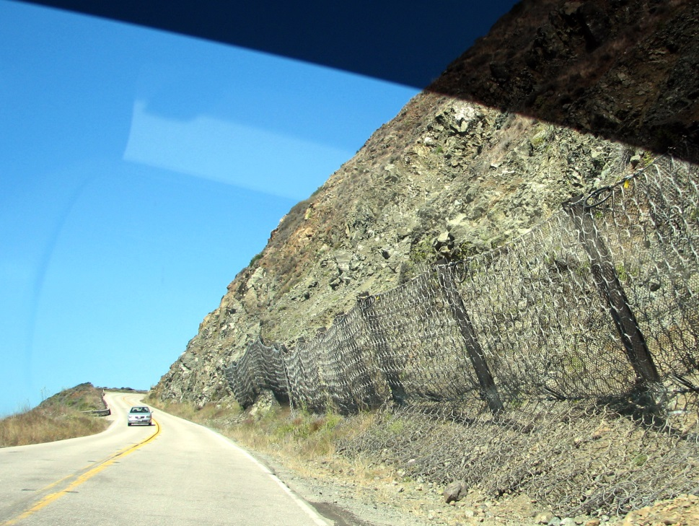
Trench and Fence Building By digging large boulder trenches and storage ditches at the base of vulnerable slopes, loose rock may be caught before it has the potential to cause any damage. Where such digging itself may destabilise the rock face, large metal mesh fences (Figure 3) or earth embankments may be erected to hold back debris and act as a barrier between rubble and settlements.
Figure 3: Boulder mesh netting (Source: Flickr Creative Commons user emdot)

Soft Engineering Techniques are used less frequently.
Some examples of soft engineering include:
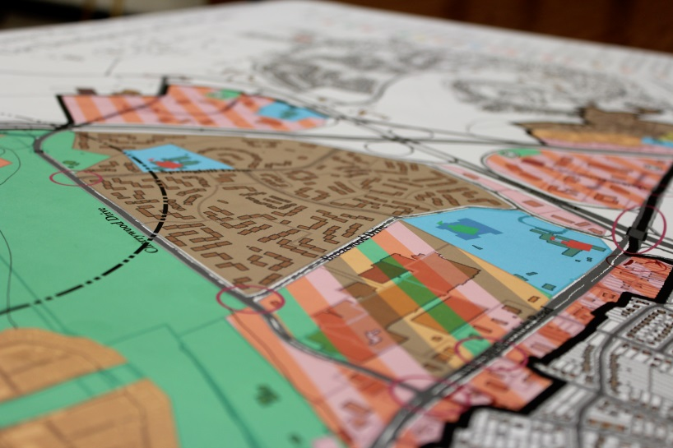
Land Use Zonation Areas that are vulnerable to repeated landslide activity often place planning restrictions on how the land closest to slope sides can be used. Key municipal buildings such as hospitals, emergency service hubs and schools are only allowed to be built in the safest areas of the settlement.
Figure 4: Land use zoning (Source: Flickr Creative Common user Matt’Johnson)

Education and public awareness campaigns Educating the general public about how best to prepare for and react to a landslide can dramatically reduce the number of casualties and damage to property when they do happen. This might involve drills that simulate evacuation procedures. People who live closest to the slope in question can also be easily trained to spot the warning signs that a landslide is about to happen and help researchers to monitor vulnerable slopes.

