Australia: End of Unit Assessment Answers

Teacher may choose to read questions out to children if necessary.
Write the correct answer or circle the correct answer.

1. Tick the statements that are true. (2)

* Australia is a continent ✓
* Australia is part of the United States of America
* Australia is a country✓

2. Australia has lots of beaches you can visit. (1)

TRUE ✓ FALSE

3. Why are there so many beaches? (1)
Australia is an island and so is surrounded by coast. Beaches are found on coasts.

4. Name one of the oceans that meets Australia’s shores. (1)
Choose from: Indian Ocean, Pacific Ocean, Southern Ocean

5. Name two of the different landscapes you might find in Australia. (2)
Choose from: rainforests, mountains, deserts

6. Australia gets a lot of sunshine and nice weather but sometimes the weather can cause a disaster. What kind of disaster might the weather create? (1)
Drought, cyclone, bushfire.

7. Circle the Australian flag. (1) 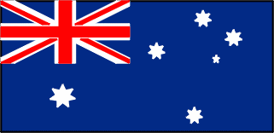

8. The summer season in Australia happens during the same months as it does in the UK. TRUE or FALSE? (1)
TRUE FALSE ✓

9. After Australia was settled by people from Europe, what language was mostly spoken? (1)
a) French b) English ✓ c) German d) Spanish

10. Whilst mining and farming is important in Australia why do fewer people work in these areas than they used to? (1)
Machines now do much of this type of work so less people are needed in this industry.

11. What is the population of Australia? (1)
a) 22 thousand b) 220 thousand c) 220 million d) 23 million ✓

12. Would you rather live in rural or urban Australia? Why? (3)
Pupils write three reasons and explain why they would like to live in rural/urban areas.

