The Totem Pole Factfile

Location: Cape Hauy, Tasman National Park, Tasmania, Australia.
Height: 65 metres high, and 4 metres wide at the base.
Rock type: Dolerite – a form of basalt, which is an igneous rock.
Background: The Totem Pole is part of the Tasman National Park, as it is part of the many miles of rugged coastline and diverse forest ecosystems, which contain several species of rare plant. The park also includes many small islands and the southern end of the park has some of the highest and most spectacular cliffs in Australia. The National Park is a very popular area for tourism as it is within a few hours drive of the main city on the island, Hobart.
Recreation: The Totem Pole is thought to be one of the hardest rock climbing routes in Australia, with hundreds of climbers attempting the climb every year. The area also offers some of the best coastal walks in the whole of Australia.
Plants and wildlife: Australian fur seals; fairy penguins; dolphins; whales; sea kelp; gannets; terns; sea eagles
Related links:
http://news.bbc.co.uk/1/hi/business/3694295.stm
http://www.parks.tas.gov.au/natparks/tasman/activities.html

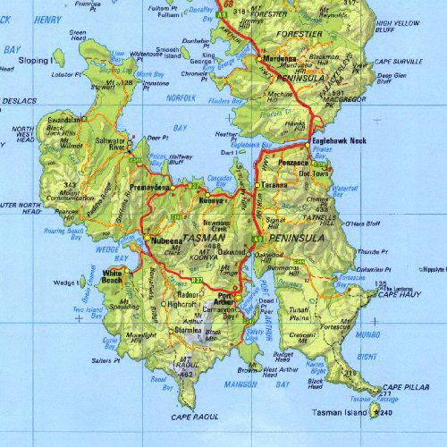
The Totem Pole

