Staff information

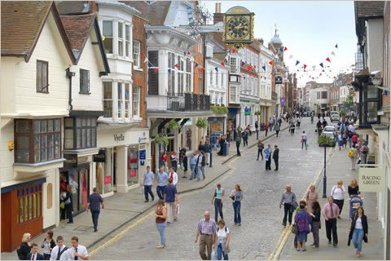

Groups need to work together to complete the following 4 tasks by completing the relevant sections of the booklet:

- Read the Guardian article on ‘Cloning UK towns’ and answer the questions in the booklet.
- ‘Higher or Lower’: predict how Guildford compares to the rest of England and Wales for the following:
  - Housing type
  - House prices
  - Crime levels
  - Satisfaction with the local area
- Shopper Survey: add two extra questions of your choice to the questionnaire grid provided, to help decide whether Guildford is a clone town or not (there will be a prize for the best question…!!)
- Survey of people’s satisfaction with the local area: add two further questions to the survey to find out how people feel.

Central Guildford (3 tasks):

- House Price Survey (Estate Agents) x2

For both routes complete the following:

- Clone Town Survey x2 routes (see maps)
- Shopper Survey (up to 9 people, calculate average)

Guildford’s Housing Areas (4 tasks):

For both areas complete the following:

- A tally of the different housing types.
- A photo environmental quality assessment.
- A survey of any evidence of crime.
- A questionnaire about people’s satisfaction with their local area.

Please could you complete the following:

(1) Students
Issues / problems experienced during the day:

(2) Fieldwork organisation: suggested improvements
Organisation of activities:

Work booklet:

Map packs:

Staff information:

Initials: _________ Thank you for your help.

