How much could I save?

Visit http://www.mysupermarket.co.uk to compare the prices of the following supermarket items:

A packet of 9 chocolate Penguin bars

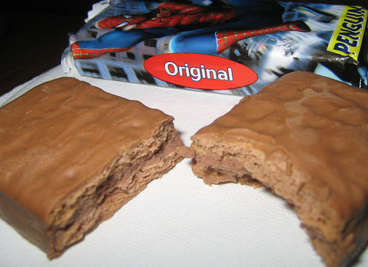

Supermarket | Price £

Image by Flickr user Leff and licensed for reuse under Creative Commons license

A bag of clementines

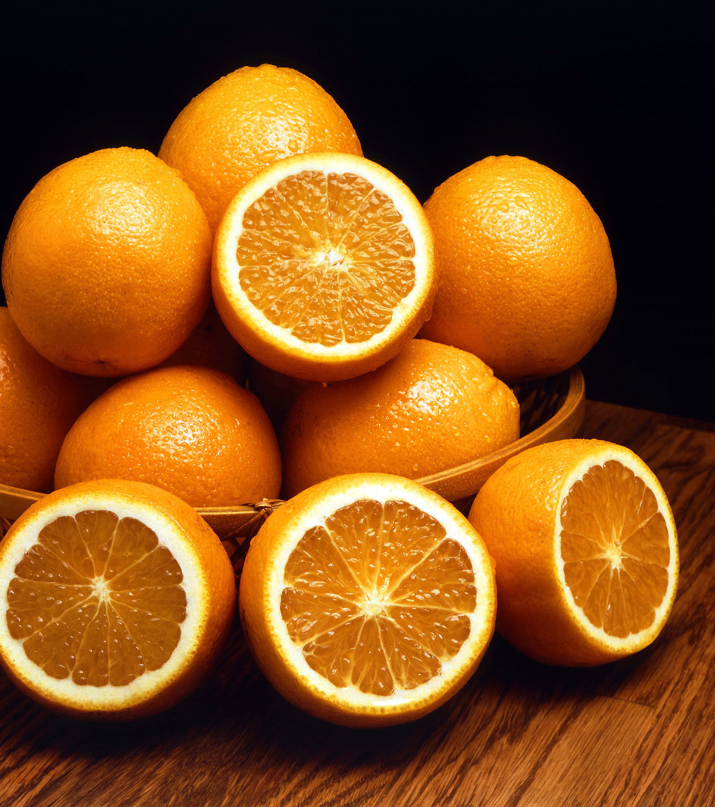

Supermarket | Price £

How much could I save?

A whole free range chicken

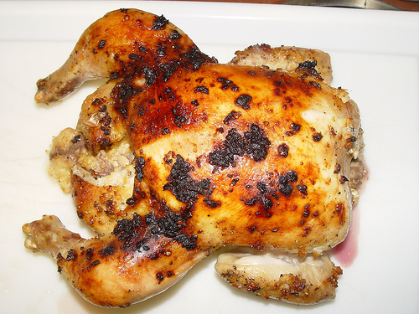
Supermarket | Price £

Image by Flickr user Matthew Saunders and licensed for reuse under Creative Commons license

A packet of 80 Clipper Fairtrade Teabags

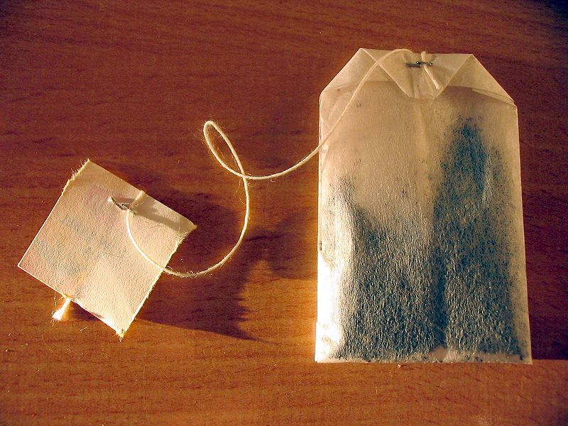

Supermarket | Price £

Wikimedia commons image by Tomasz Sienicki licensed under the creative commons license.

How much could I save?

A 2 litre bottle of Diet Coca-Cola

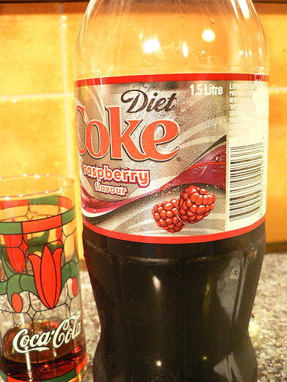
Supermarket | Price £

Image by Flickr user Brenda Anderson and licensed for reuse under Creative Commons license

A packet of 24 Weetabix

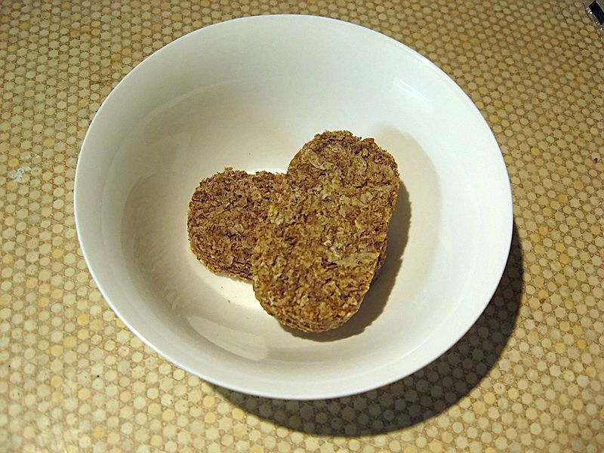

Supermarket | Price £

Wikipedia public domain image by Jongleur 100

