
Using
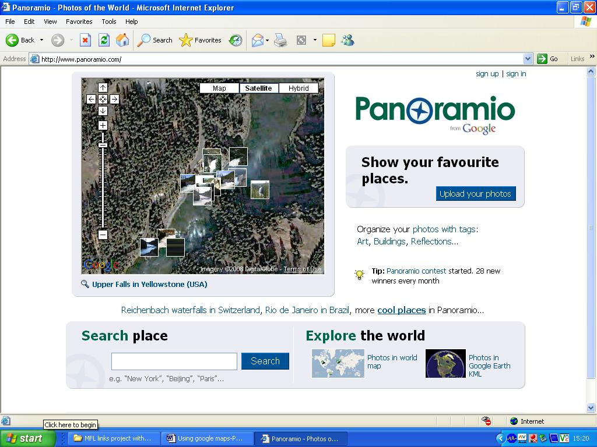

Go to http://www.panoramio.com/

- Sign in or Sign up to
access an account for yourself

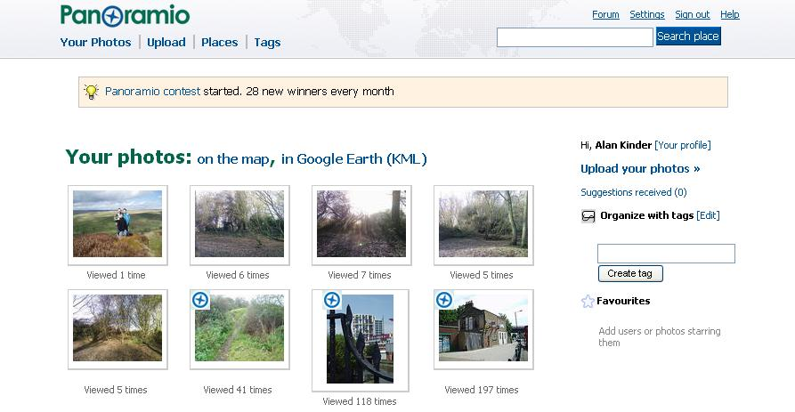
- Go to Upload your photos

- Browse to find a photo
(from your computer)

- Upload it

- Add a title (and notes if wanted)

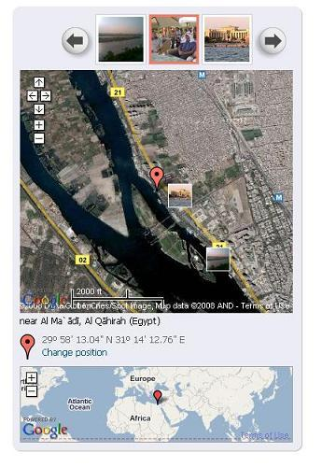
- MAP the photo

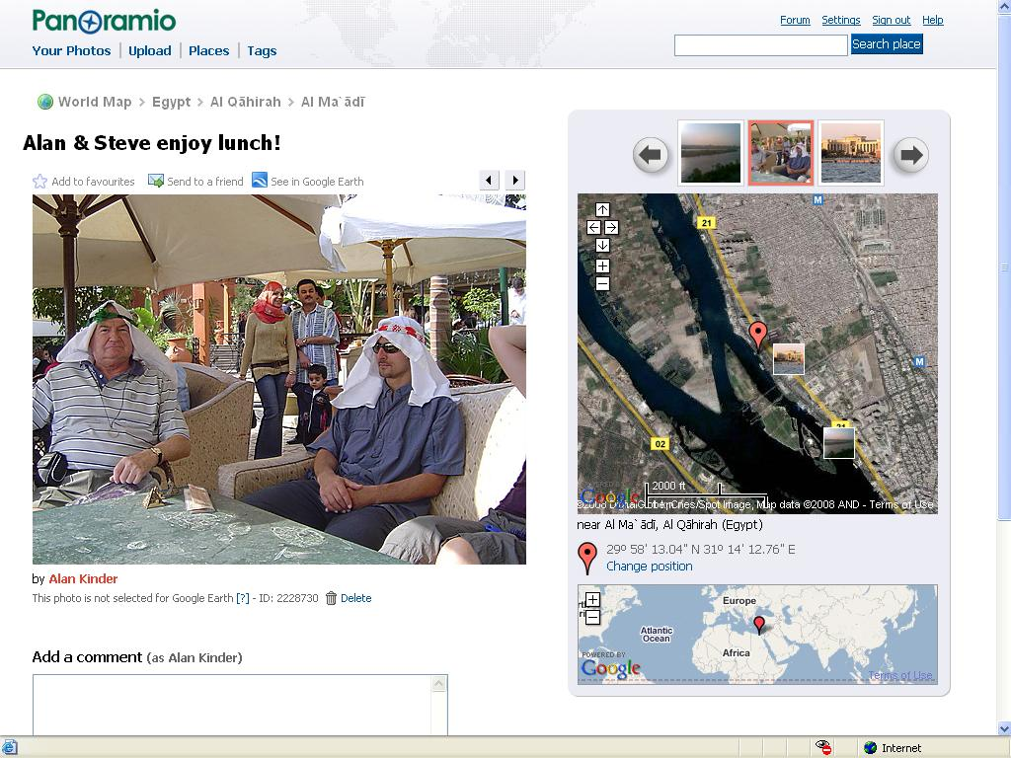

- FINISH and view your photo e.g. in Google Earth

- Check the PROPERTIES of your photograph. Right mouse button – then highlight and copy the URL… (i.e. to paste into Google Maps).

