Investigating: Mississippi Flooding
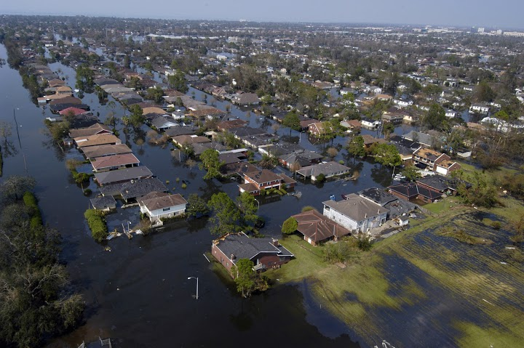Mississippi © Wikipedia
- Visit websites below to find out what happened
- Using this information use the storyboard template to show what caused the flood and what its impacts were.
- Overleaf, then complete the Mississippi Floods details, causes and impacts table.

Links
Go to National Geographic website http://news.nationalgeographic.com/news/2011/05/pictures/110510-mississippi-river-memphis-tennessee-flood-record-crests-nation/
Go to National Geographic Website http://voices.nationalgeographic.com/2011/05/03/mississippi-floods-can-be-restrained-with-natural-defenses/
Go to NOAA website http://www.srh.noaa.gov/jan/?n=2011_05_ms_river_flood

Go to BBC News website http://www.bbc.co.uk/news/world-us-canada-13337548

Go Nature website: website http://www.nature.com/news/2011/110513/full/news.2011.289.html
Mississippi Flooding: Storyboard
Mississippi Flooding: details; causes and impacts
Details | Causes | Impacts

